**AXON SALES DOCUMENT**

**Introduction**

The purpose of building a sales dashboard and reports for AXON retail car-selling company is to provide real-time insights and comprehensive analysis of various sales-related metrics. This enables informed decision-making, strategy refinement, and overall business improvement.

**Overview**

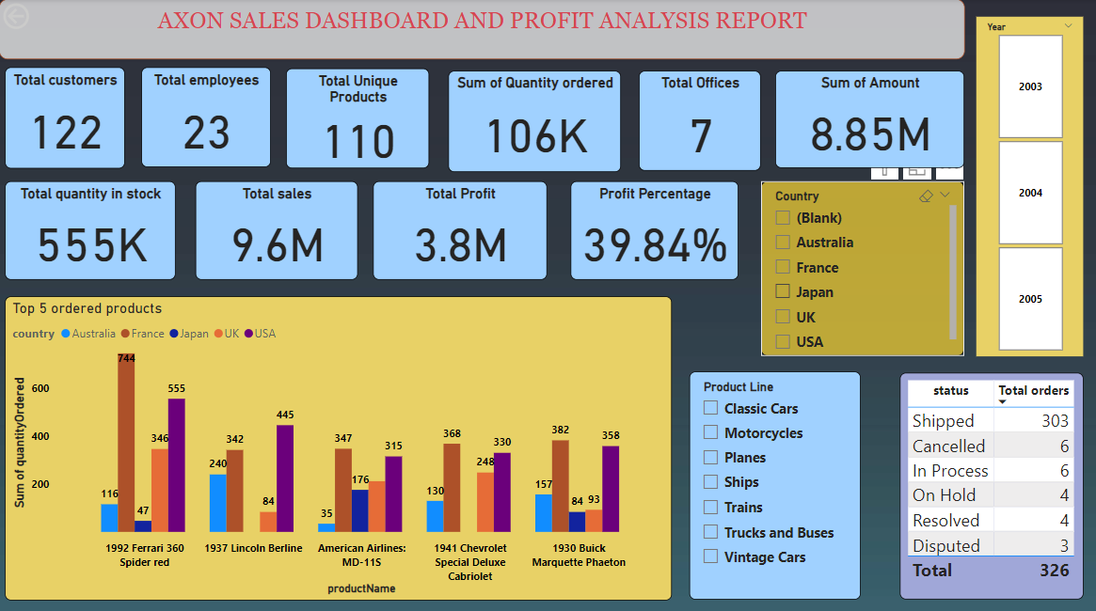

The above dashboard shows Total customers **122** ,Total employees **23** ,Total Unique Products **110** ,Sum of quantity ordered by total customers **106k** ,Total quantity in stock with the vendors **555k**,Total offices **7**,Total Sales by all vendors **9.6 millions** and finally Total Profit **3.8 millions.**

I used **Clustered column chart** to get the **count of top 5 products sold** with respect to the country and I applied **advanced filtering** to get the **top 5 ordered products** out of them which helps in evaluating production rate of that products by the company.

I also used a **slicers**  for year and for countries of offices to know the top 5 selling products in three years 2003,2004,2005 and also slicer for Product Line.

A **table** has been used to know the total **count of total orders** as well as **status of the orders of specific product in specific country.**

**Insights:**

* **“1992 Ferrari 360 Spider red”** a product of classic cars is the highly ordered product among all has a total of **1808 orders** from all over the countries.so it is the product in high demand.
* Since the demand for **“1992 Ferrari 360 Spider red”** is high, so the Production rate should be increased.
* **France** is the country which has high orders for **“1992 Ferrari 360 Spider red”**. So here the Demand and Supply should be taken care of to maintain as best as earlier sales.

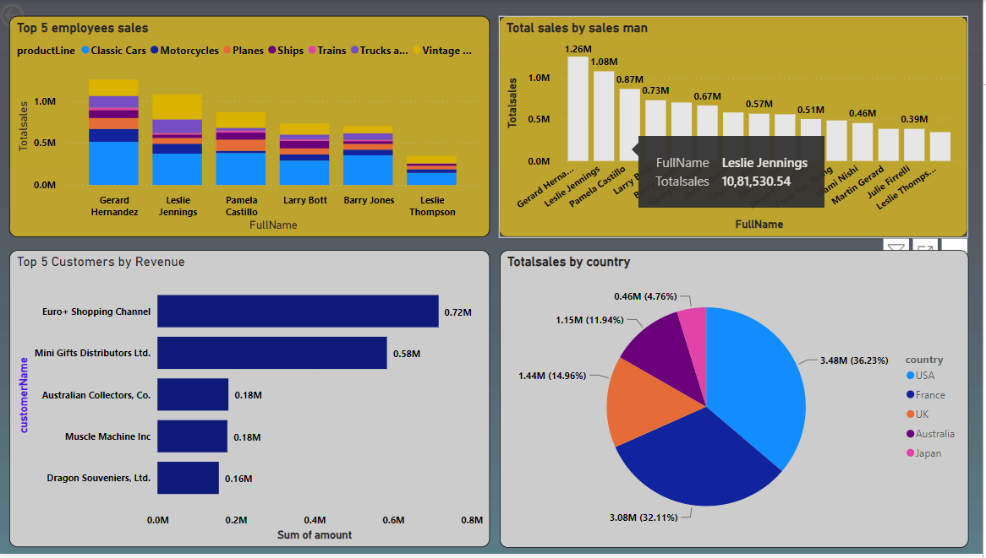

Here I used **stacked column chart** to get the **employees sales by category**, **Clustered Bar Chart** to get the **Total sales with respect to the sales man**, **Stacked Bar Chart** to get the **Customer Name with respect to the Revenue, Pie Chart** to get Total Sales with **respect to the Country**

**Insights :**

* The **top 5 sales representative** can be awarded and encouraged for more performance in sales and the low performance sales representatives can be trained on how to perform sales more effectively.

**“Gerard Hernandaz”** is the best sales representative who performed 1.26 millions of sales. Most of the sales are done in **Classic Cars** by Gerard Hernandaz.

* The **top 5 Customers** will be given offers on their highly making orders and encouraging them to perform the best in the business.

**“Euro + Shopping Channel”** is the best customer in making the high revenue.

* **Total Sales with respect to the country** can be drawn using Pie Chart so that business can be improved in less performing countries by advertising and giving some discounts on the products.

**“USA”**  is performing the best in sales out of all other countries.

* “Classic Cars” are the most selling category under the product line in almost all of the countries.

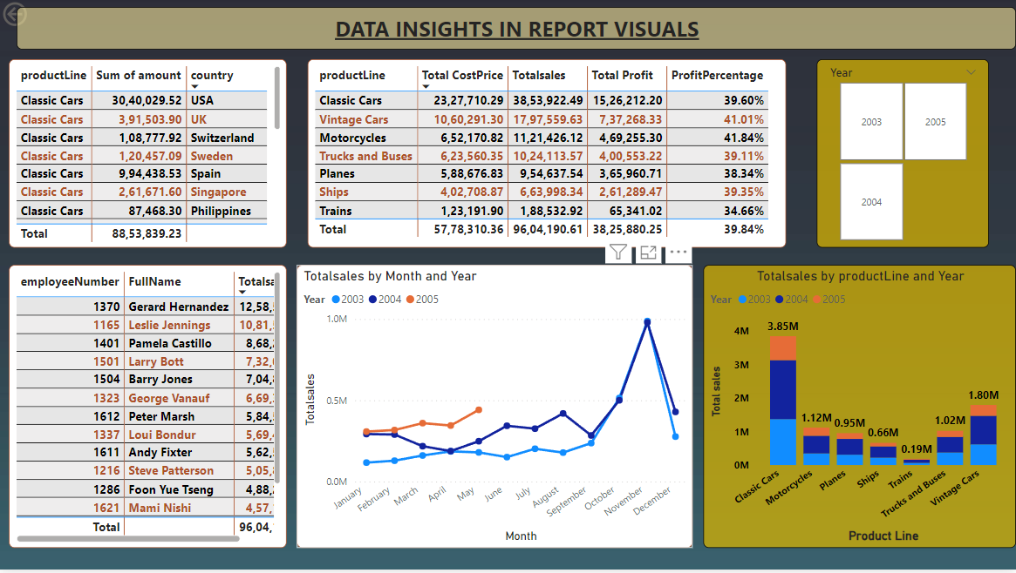

Here I used **Table visuals** to **get Total Cost Price, Total Sales, Total Profit, Profit percentage with respect to the Product Line** and used another **Table Chart to know the Classic Cars sales with respect to the country** and used a slicer for Year.

A **stacked Column Chart** has used to get the **Total sales by Product line with respect to the Year.**

A **Line Chart** has been used to get the **Total Sales with respect to the Month and Year.**

A slicer for Year has also used.

**Insights :**

* Sales have been gradually increasing from September to November and gradually decreasing till December.

From **2.3 millions** in sept to **9.8 millions** in December

* More sales are happened in the year **2004** in each Product Line.
* Motor Cycles got High Profit % approximately **42 %** as per their sales with respect to al the years.
* Classic Cars have best sales in USA which makes a business of about **3 millions.**
* Total sales of company is **9.6 millions** and Total profit is **3.8 millions.**